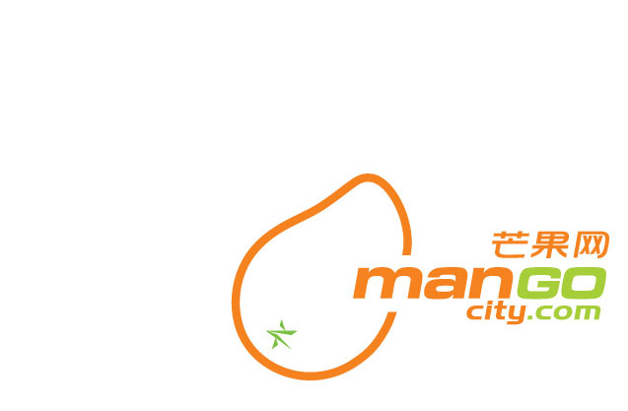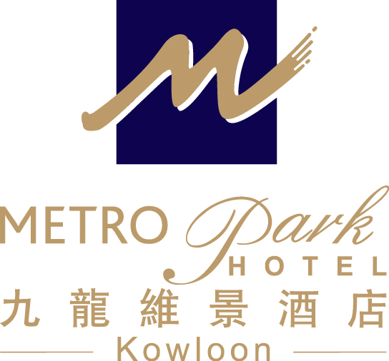
International Conference on Preconditioning Techniques for Scientific and Industrial Applications --Hong Kong Baptist University (23-27 August 2009)

Accommodation Reservation Form
Metropark Hotel Kowloon

Guest Name: Mr/Ms/Mrs/Prof./Dr. (First name) (Last name)

Contact : (Tel) (Fax) (Email)

Arrival Date: (DD/MM/YY) Departure Date: (DD/MM/YY)

Room category & Package: Comfort Single/Double Room

1. Room only: HK$600 net per room per night
2. Room with 1 pax breakfast : HK$660 net per room per night
3. Room with 2 pax breakfast : HK$720 net per room per night

No. of Room(s)

Special Request: Non-smoking Smoking

Airport Shuttle: Airport→Hotel Hotel→Airport

* The rate is inclusive of 10% service charge and is subject to the hotel confirmation.
- Airport transfers by shuttle bus at special rate HK$98 per person per way ; the shuttle bus departs Airport / Hotel on an regular basis (please approach Airport Representatives at Counter “B17” in the Airport’s Arrival Hall / Hotel Reception)
- Welcome fruit set up and beverages upon arrival
- Free local telephone calls
- Free in - room broadband internet access (unlimited usage)
- Free later check out until 15.00 (subject to Room Availability)
- Free use of Hotel’s swimming pool and fitness room facilities

- All bookings should be guaranteed by a credit card.

Booking Guaranteed By: Amex Visa Master Diners
Notes: 1. The special rate is only applicable to delegates of the above conference.
2. The deadline for making reservation is on or before 16 August 2009 and the accommodation is subject to availability.
3. All the expenses are on guest own account.
4. In case of ‘No show’ or ‘Late Cancellation’, a penalty charge which is equivalent to 1 night’s room rental will be levied.
5. Cancellation without penalty charge must be reported to Hotel at least 72 hours prior to the scheduled arrival date.

Card holder: Card No. : Expiry Date:

Date of Application: Signature:

For reservations, please contact -Metropark Hotel Kowloon, S & M Office
Ms. Anita Hung (Assistant Business Development Manager)
Tel：（852）21973431 Fax：（852）2760 3603

E-mail：abdm.hkkl@metroparkhotels.com

Metropark Hotel Kowloon 九龍維景酒店
Address : 75 Waterloo Road, Kowloon, Hong Kong 香港九龍窩打老道75號

